## Design Document- Psychiatric Note

Camino Real MH Services

Date: 11.18.2015

Version 2.3

## Summary

The purpose of this design document is to outline the service note that doctors would use for a visit and allow for calculation of E&M Code to bill using Standard E&M coding rules and requirements.

### *Purpose*

Psychiatrists at Camino Real will complete the Psychiatric Note to document comprehensive psychiatric services provided to the client.

## System Design

#### 1.0 General Tab



#### Requirements

|  |  |  |  |
| --- | --- | --- | --- |
| Field | Required | Response Options | Validation Message |
| Adult/Child/Adolescent | Yes | Via Radio Button   * Adult * Child/Adolescent | General – Adult or Child/Adolescent is required |
| ~~Walk-in/Scheduled Appointment~~ | ~~Yes~~ | ~~Via Radio Button~~   * ~~Walk-In~~ * ~~Scheduled Appointment~~ | ~~General-Walk-in/Scheduled appointment is required~~ |

#### Rules

|  |  |
| --- | --- |
| Field  Field | Rule  Rules |
| Child/Adolescent | Adult/Child/Adolescent radio buttons will initialize based on clients DOB but allow User to change the response.  Less than 18 – default radio button to Child/Adolescent and the Child/Adolescent Tab will be enabled  18 and over – default radio button to Adult |
| Walk-in/Scheduled Appointment | Remove these two radio button |

#### Persons present other than consumer for exam



***Requirements***

|  |  |  |  |
| --- | --- | --- | --- |
| Field | Required | Response Options | Validation Message |
| Persons Present Other Than Consumer for exam | No | Via comment box | None |

#### Today’s Chief Complaint/Reason for Visit

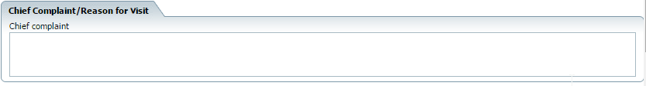

***Requirements***

|  |  |  |  |
| --- | --- | --- | --- |
| Field | Required | Response Options | Validation Message |
| Today’s Chief Complaint/Reason for Visit | Yes | Via comment box | Chief Complaint/Reason for visit is required |

#### Initial Psychiatric Evaluation Presenting Problem

New Section



***Requirements***

|  |  |  |  |
| --- | --- | --- | --- |
| Field | Required | Response Options | Validation Message |
| Initial Presenting Problem | Conditional | Via comment box | General – Initial Presenting Problem is required |

#### Rules

|  |  |
| --- | --- |
| Field  Field | Rule  Rules |
| Initial Presenting Problem | * Need recode table to identify procedure codes to enable/disable this comment box |

#### 1.4 Problem



**Requirements**

|  |  |  |  |
| --- | --- | --- | --- |
| Field | Required | Response Options | Validation Message |
| Problem | Yes | Via textbox | General – Problem X – Problem is required |
| Problem Button | N/A | Pop Up | N/A |
| Type of Problem | Yes | Via Dropdown   * Acute * Chronic | General - Problem-type of Problem is required |
| Severity | No | Via Dropdown   * None * Mild * Moderate * Severe | General – Problem – At least two items are required. |
| Duration | No | Via textbox   * Less than a day * 1-7 days * 7-30 days * 1-3 months * 3-6 months * More than 3 months | General – Problem – At least two items are required. |
| Modifying Factors | No | * Via textbox | General – Problem – At least two items are required |
| Time of Day | No | Via Checkboxes   * All Day * Morning * Afternoon * Night | General – Problem – At least two items are required. |
| Context | No | Via textbox | General – Problem – At least two items are required. |
| Location where problem occurs | No | Via checkboxes   * Home * Work * School * EVERYWHERE * Other/Text field | General – Problem – At least two items are required. |

#### Rules

|  |  |
| --- | --- |
| Field  Field | Rule  Rules |
| Problem 1 | Add Problem Hyperlink   * When this is selected, a new Problem section will be added. The number of Problem will increase by one   Delete Problem   * User has the ability to delete a Problem from the Problem list. To remove a Problem, user clicks the ‘X’ next to the Problem description box. |
| Problem Pop Up | * Problem pop up – will contain a list of all active diagnosis for a client * User can select one or multiple Problem * Once user has selected the ‘OK’ button the Problem will be populated in the Problem comment box. Use can edit if needed |
| Location where problem occurs | The textbox will appear and is required when user selects Other from the drop down menu. |
| General – Problem – At least two items are required. | The validation should be based on 2 of the 6 questions must be answered. Only these 6 questions are included in the rule   * Severity * Modifying Factors * Duration * Time of Day * Context * Location where problem occurs |
| Problem | Problem section should initialize from previous note unless the Problem has been marked ‘resolved’. |

#### 1.5 Side Effects



***Requirements***

|  |  |  |  |
| --- | --- | --- | --- |
| Field | Required | Response Options | Validation Message |
| Side Effects | Yes | Via radio buttons   * None * Specify/Text Box | General – Side effects is required |

#### Rules

|  |  |
| --- | --- |
| Field  Field | Rule  Rules |
| Specify | The textbox will appear and is required when user selects Specify from the options. |

#### 1.6 Plan- Last Visit

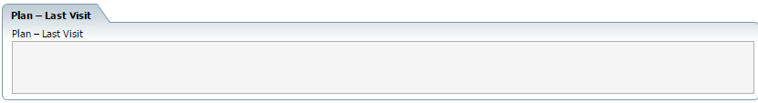

#### Requirements

|  |  |  |  |
| --- | --- | --- | --- |
| Field | Required | Response Options | Validation Message |
| Plan – Last Visit | n/a | Via textbox pulled in  (disabled) | None |

#### Rules

|  |  |
| --- | --- |
| Field  Field | Rule  Rules |
| Plan – Last Visit | Pulls in the Last Visit information from the ‘Medical Decision Making’ tab field ‘ Plan’  Pull in plan information from previous medical note  Put a date in front (e.g. 10/25/2013 – xxxxx) |

#### 1.7 History of Present Illness



#### Requirements

|  |  |  |  |
| --- | --- | --- | --- |
| Field | Required | Response Options | Validation Message |
| Psychiatric History | Yes | Via text box/checkbox   * Text Box (always required) * Reviewed With Changes (Optional) | General – History – Psychiatric History comment box is required |
| Family History | Yes | Via text box/checkbox   * Text Box (always required) * Reviewed With Changes (Optional) | General – History – Family History comment box is required |
| Social History | Yes | Via text box/checkbox   * Text Box (always required) * Reviewed With Changes (Optional) | General – History – Social History comment box is required |

***Rules***

|  |  |
| --- | --- |
| Field  Field | Rule  Rules |
| Psychiatric History | Initialize from last psychiatric note and allow changes |
| Family History | Initialize from last psychiatric note and allow changes |
| Social History | Initialize from last Psychiatric note and allow changes |

#### 1.8 Review of Systems & Active Medical Problems



#### Requirements

|  |  |  |  |
| --- | --- | --- | --- |
| Field | Required | Response Options | Validation Message |
| Review of Systems | No | Via Checkbox   * Psychiatric * Genitourinary * Neurological * Cardio/Vascular * Musculoskeletal * Gastrointestinal * Immune * Hem/Lymph * Constitutional * Integumentary * Eyes * Ear, Nose, Mouth, Throat * Endocrine * Respiratory * All others negative | None |

#### Rules

|  |  |
| --- | --- |
| Field  Field | Rule  Rules |
| Psychiatric | Psychiatric should default to checked |

#### 1.9 Allergies/Substance Use Hx/Medical Problems

Remove the Network 180 section and replace with this new section



#### Requirements

|  |  |  |  |
| --- | --- | --- | --- |
| Field | Required | Response Options | Validation Message |
| Allergies | No | Via Textbox | None |
| Open Allergy Button | No | Open Allergy Button – See rules | None |
| Refresh Button | No | Refresh Button – see rules | None |
| Substance use | No | Via text box | None |
| Non-Smoker/Smoker | Yes | Via radio buttons   * Non-Smoker * Smoker | General – Allergies/Substance Use Hx/Medical Problems – Non-smoker/Smoker is required |
| How much | Conditional | Via text field | General – Allergies/Substance Use Hx/Medical Problems – specify # of cigarettes per day is required |
| Other Tobacco Use | No | Via Text field | None |
| Caffeine Consumption | No | Via Text field | None |
| Pregnant | Yes | Via Radio Buttons   * Yes * No * N/A | General – Allergies/Substance use Hx/Medical Problems – Pregnant is required |
| Last Menstrual Period | No | Via text field | None |

***Rules***

|  |  |
| --- | --- |
| Field  Field | Rule  Rules |
| Open Allergy Button | When selecting this button, user will be redirected to the SmartCare Rx. The user can enter the information and save it. |
| Refresh Button | When user selects the refresh button it will bring in the most current allergies for the client. |
| Substance Use | Initialize from last psychiatric note and allow changes |
| Non Smoker/Smoker | If Smoker is selected, then the specify # of cigarettes per day text box is required.  Initialize from last Psychiatric note and allow changes |
| Other Tobacco Use | Initialize from last Psychiatric note and allow changes |
| Caffeine Consumption | Initialize from last Psychiatric note and allow changes |
| Pregnant | For 1st Note- Default answer to N/A If Male or if Female and age is > 55 and < 9.  Not 1st Note - Initialize from last Psychiatric note and allow changes. |

#### 1.10 PCP/Other Providers

Hide this field

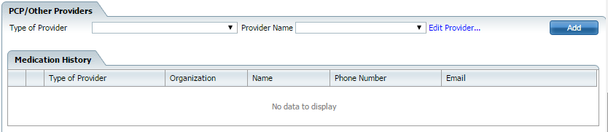

#### 2.0 Vitals



#### Requirements

|  |  |  |  |
| --- | --- | --- | --- |
| Field | Required | Response Options | Validation Message |
| Current vitals | NA | System generated post entering on flow sheet | None |
| Previous vitals | NA | System generated via previous vitals flow sheet data | None |

#### Rules

|  |  |  |  |
| --- | --- | --- | --- |
| Field | Rule | Validation  Validation Message | Initializations Occurring on Signature |
| Open vitals flow sheet | When selecting this button, user will be redirected to the vitals flow sheet. The user can enter the information and save it. After selecting the red x on the flow sheet, the user is redirected back to the note-exam tab | None | None |

#### Musculoskeletal

#### 

#### Requirements

|  |  |  |  |
| --- | --- | --- | --- |
| Field | Required | Response Options | Validation Message |
| Musculoskeletal | Yes | Via checkbox   * Muscle strength normal * Muscle strength abnormal * Tone * Tics, tremors, or abnormal movements * EPS | Exam – Musculoskeletal is required |

#### Gait and Station

#### 

#### Requirements

|  |  |  |  |
| --- | --- | --- | --- |
| Field | Required | Response Options | Validation Message |
| Gait and Station | Yes | Via checkbox   * Gait normal * Gait abnormal | Exam – Gait and Station is required |

#### Mental Status Exam



#### Requirements

|  |  |  |  |
| --- | --- | --- | --- |
| Field | Required | Response Options | Validation Message |
| Alert and Oriented X4 | Yes | Via radio buttons/textbox   * Yes * No | Exam – Mental Status Exam – Alert and Oriented X4 is required |
| Grooming and Hygiene | Yes | Via radio buttons/textbox   * Good * Fair * Disheveled * Poor * Textfield | Exam-Mental Status Exam- Grooming and Hygiene is required |
| Eye Contact | Yes | Via Radio Button/textbox   * Good * Avoidant * None * textfield | Exam – Mental Status Exam – Eye contact is required |
| Cooperative/Pleasant | Yes | Via radio button/textbox   * Yes * No * Textfield | Exam – Mental Status Exam – Cooperative/Pleasant is required |
| Speech | Yes | Via radio button/textbox   * Regular rate, rhythm, and volume * Specify/textbox | Exam – Mental Status Exam – Speech is required |
| Psychomotor | Yes | Via radio button   * Normal * Increased * Decreased * Other/Textfield | Exam – Mental Status Exam – Psychomotor is required |
| Mood | Yes | Via checkboxes and 1 textfield   * Euthymic * Labile * Dysphoric * Elevated * Anxious * Irritable * Expansive * Textfield | Exam – Mental Status Exam – Mood is required |
| Affect | Yes | Via checkboxes and 1 textfield   * Broad * Flat * Blunted * Constricted * Guarded * textfield | Exam – Mental Status Exam – Mood and affect is required |
| Thought Processes | Yes | Via checkboxes   * Logical * Illogical * Circumstantial * Tangential * Flight of Ideas * Preoccupied * Auditory Hallucinations * Delusions * Visual Hallucinations * Paranoia * Grandiose * Referential * Poverty of thought * Loose associations * textfield | Exam – Mental Status Exam – Thought Processes is required |
| Suicidal | Yes | Via checkboxes and 1 textfield   * None Reported * specify (see rules) * Ideation * Intent * Plan * Textfield | Exam – Mental Status Exam – Suicidal is required |
| Homicidal | Yes | Via checkboxes and 1 textfield   * None Reported * specify (see rules) * Ideation * Intent * Plan * Textfield | Exam – Mental Status Exam – Homicidal is required |
| Memory and Recall | Yes | Via Radio button and 1 Textfield   * Intact * Specify * Textfield | Exam – Mental Status Exam – Memory and Recall is required |
| Intelligence | Yes | Via radio buttons   * Average * Above * Borderline * Below | Exam – Mental Status Exam – Cognitively Intact is required |
| Insight and judgment | Yes | Via radio buttons and Textfield   * Good * Fair * Poor * Textfield | Exam – Mental Status Exam – Insight and judgment |
| Additional Comments | No | Text field | None |

#### Rules

|  |  |
| --- | --- |
| Field | Rules |
| Specify | When specify is selected the textbox or corresponding checkboxes (at least one in each section) is required |
| Initialization Logic | All fields initialized from the previous document including the radio buttons/text fields |
| Additional Comments | Additional comments should not be included in the EM count |

#### Changes

New section added



#### Requirements

|  |  |  |  |
| --- | --- | --- | --- |
| Field | Required | Response Options | Validation Message |
| Review | Yes | Via Radio button   * Review with changes * Review without changes * N/A | Exam- Review – at least one radio button is required |

#### Rules

|  |  |
| --- | --- |
| Field | Rules |
| Review | 1st Note – Default to N/A |

#### 3.0 Medical Decision Making Tab

#### 3.1 Medical Records Review

## 

## Requirements

|  |  |  |  |
| --- | --- | --- | --- |
| Field | Required | Response Options | Validation Message |
| Medical Records Reviewed | No | Via check box   * Labs Reviewed * Medical records reviewed * Collaboration of Care * Diagnostic tests reviewed * Other | None |
| This Visits Relevant Results | Yes - conditional | Via textbox | Medical Decision Making Labs Reviewed – This Visits Relevant Results is required |
| Labs Ordered Last Visit | No | Via Textbox | None |
| Previous Relevant Results | No | Via Textbox | None |

#### Rules

|  |  |
| --- | --- |
| Field  Field | Rule  Rules |
| Labs Ordered Last Visit | * Initialize from Previous Note. Does not print on RDL for current note. |
| This Visits Relevant Results | * Required if other or labs reviewed is selected |
| Previous Relevant Results | * Pulls in the ‘This Visits Relevant Results’ from the previous note and the ‘Previous Relevant Results’ from the previous note. The information should be listed in date order with the most recent information on top. * Since the previous relevant results is an editable field you will always need to pull this field from the previous note in case the data has changed. * Should be formatted as seen below |

#### 3.2 Medical Decision Making



#### Requirements

|  |  |  |  |
| --- | --- | --- | --- |
| Field | Required | Response Options | Validation Message |
| Subjective X | n/a | Via read only | None |
| Subjective (comment) | Yes | Via textbox | Medical Decision Making – Subjective X – Comment is required |
| Status | Yes | Via Dropdown   * Stable * Worsening * Improving * New * Resolved | Medical Decision Making – Subjective X – status is required |



#### Requirements

|  |  |  |  |
| --- | --- | --- | --- |
| Field | Required | Response Options | Validation Message |
| Plan | No | Via textbox | None |
| Plan – Last Visit | n/a | Via textbox (disabled) | None |
| Patient/Parent/Guardian…. | Yes | Via radio buttons   * Yes * No | Plan – Patient/Parent/Guardian voiced understanding… is required |
| Next Physician Visit | No | Via textbox | None |
| More than 50%.... | No | Via checkbox | None |

#### Rules

|  |  |
| --- | --- |
| Field | Rule |
| More than 50%... | Links to the 50% face time on billing code popup |
| Plan – Last Visit | Pull in plan information from previous medical note  Put a date in front (e.g. 10/25/2013 – xxxxx) |
| Patient/Parent/Guardian…. | Default to Yes |
| Plan | Once the document has been signed send a message to the primary clinician with the following information   * Plan Section from psychiatric evaluation * A hyperlink to the psychiatric evaluation * Pill Box Section if completed   Subject of message – Plan of Care From Psychiatrist |
| Next Physician Visit | This box will update the comment on Reception for this visit. Be Careful of concurrent errors.  Entry in this box will Update “Comment” field on the Reception Screen for this visit. BE CAREFUL OF CONCURRENT ERRORS!!!! |

#### 3.2 Nurse Monitor Pill Box

New Section Added



#### Requirements

|  |  |  |  |
| --- | --- | --- | --- |
| Field | Required | Response Options | Validation Message |
| Nurse will monitor pill box | No | Via radio buttons   * Yes * No | None |
| Frequency | Conditional | Dropdown   * Weekly * Bi-weekly * Twice a week * Daily * other | General – Nurse will monitor pill box frequency is required |
| Comment | No | Via textbox | none |

#### Rules

|  |  |
| --- | --- |
| Field  Field | Rule  Rules |
| Nurse will monitor pill box | * If nurse will monitor pill box = yes, then frequency is required * If ‘other’ is selected from frequency dropdown then show an additional text field next to the dropdown that is required. Validation Message ‘General-Nurse will monitor pill box – frequency other textbox is required’ * DEFAULT YES/NO FROM LAST NOTE, IF NULL THEN SET TO “NO” |

#### c

#### Requirements

|  |  |  |  |
| --- | --- | --- | --- |
| Field | Required | Response Options | Validation Message |
| Orders | No | Via checkbox and textbox   * Labs * EKG * Radiology * Consultations * Textfield | None |
| Labs Last ordered | No | Via comment box | None  Will be grayed out if labs last ordered unless Lab ordered with comments box is filled out |

#### Rules

|  |  |
| --- | --- |
| Field | Rule |
| Orders | When the user selects the check box (Labs, EKG, Consultations) it will preselect the E&M coding section. |
| Place Order | Disable button |
| Labs Last order | Need to pull in previous lab orders should include date, lab order, ordering provider. This will be the comments box Orders will not be setup  This section will not be printed on the PDF |



Requirements

|  |  |  |  |
| --- | --- | --- | --- |
| Field | Required | Response Options | Validation Message |
| Ordered Medications | No | Via checkbox | None |
| ~~The medications below were reviewed with the client~~ | ~~No~~ | ~~Via radio button~~ |  |
| Risk/benefits have been discussed…. | Yes | Via radio button   * Yes * No * N/A | MDM – Medications – Risk/benefits/side effects have been discussed… is required |
| Current medications | N/A | Disabled textbox (system generated) | N/A |
| Not ordered by Camino Real Community Services | N/A | Disabled textbox (system generated) | N/A |
| Medications Discontinued This Visit | NA | Disabled textbox (system generated) | N/A |
| Information and education | N/A | Via textbox | None |

#### Rules

|  |  |
| --- | --- |
| Field  Field | Rule  Rules |
| Open SmartCareRx | When selecting this, the system will open SmartCareRx to the patient summary page of current client that is open in SmartCare |
| View medication history | When selecting this, the system will open to the medication history report page in SmartCareRx for the current client that is open in SmartCare |
| Risk/benefits have been discussed…. | Default to Yes  If NO comment box required |

#### Initialization Logic

|  |  |
| --- | --- |
| Field | Description |
| Current medications | Pulled in from SmartCareRx   * Only active medications * Prescribed medications only |
| Not ordered by Camino Real Community Services | Pulled in from SmartCareRx   * Only active medications * Prescribed medications only |
| Medications discontinued in this session | Disabled textbox (system generated) Pulled in from SmartCareRx |

## Child Tab

Child tab should appear before AIMS

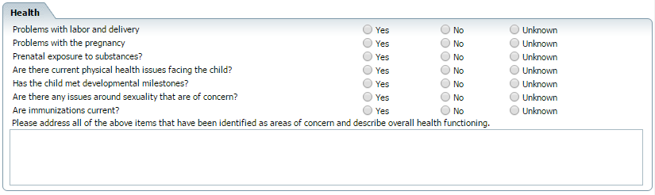

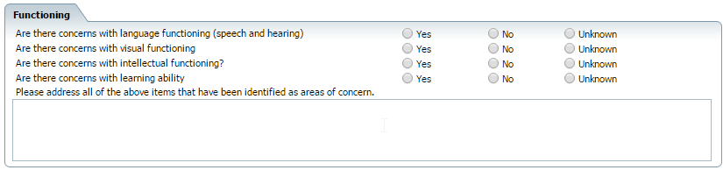

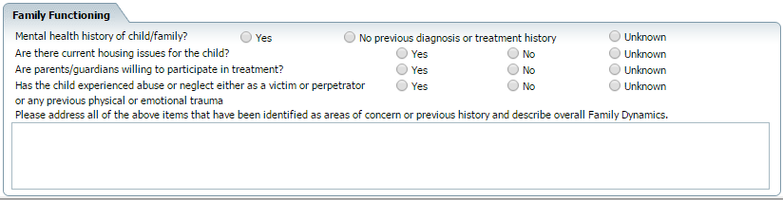

***Health***

|  |  |  |  |  |
| --- | --- | --- | --- | --- |
| Field | Required | Response Options | Global Code  Category | Validation Message |
| Problems with labor and delivery? | No | Via radio buttons   * Yes * No * Unknown | None | None |
| Problems with the pregnancy? | No | Via radio buttons   * Yes * No * Unknown | None | None |
| Prenatal exposure to substances? | No | Via radio buttons   * Yes * No * Unknown | None | None |
| Are there current physical health issues facing this child? | No | Via radio buttons   * Yes * No * Unknown | None | None |
| Has the child met developmental milestones? | No | Via radio buttons   * Yes * No * Unknown | None | None |
| Are there any issues around sexuality that are of concern? | No | Via radio buttons   * Yes * No * Unknown | None | None |
| Are immunizations current? | No | Via radio buttons   * Yes * No * Unknown | None | None |
| Please address all of the above items that have been identified as areas of concern and describe overall health functioning. | No | Textbox | None | None |

***Functioning***

|  |  |  |  |  |
| --- | --- | --- | --- | --- |
| Are there concerns with intellectual functioning? | No | Via radio buttons   * Yes * No * Unknown | None | None |
| Are there concerns with visual functioning? | No | Via radio buttons   * Yes * No * Unknown | None | None |
| Are there concerns with intellectual functioning? | No | Via radio button   * Yes * No * Unknown | None | None |
| Are there concerns with learning ability? | No | Via radio buttons   * Yes * No * Unknown | None | None |
| Please address all of the above items that have been identified as areas of concern. | No | Textbox | None | None |

***Family Functioning***

|  |  |  |  |  |
| --- | --- | --- | --- | --- |
| Field | Required | Response Options | Global Code  Category | Validation Message |
| Mental health history of child/family? | No | Via radio buttons   * Yes * No previous diagnosis or treatment history * Unknown | None | None |
| Are there current housing issues for the child? | No | Via radio buttons   * Yes * No * Unknown | None | None |
| Are parents/guardians willing to participate in treatment? | No | Via radio buttons   * Yes * No * Unknown | None | None |
| Has the child experienced abuse or neglect either as a victim or perpetrator or any previous physical or emotional trauma? | No | Via radio buttons   * Yes * No * Unknown | None | None |
| Please address all of the above items that have been identified as areas of concern or previous history and describe overall Family Dynamics. | No | Textbox | None | None |

#### Rules

|  |  |
| --- | --- |
| Field | Rule |
| All fields | All fields should initialize from previous note. |

#### AIMS TAB – Use the new AIMS that was created for Camino

#### 

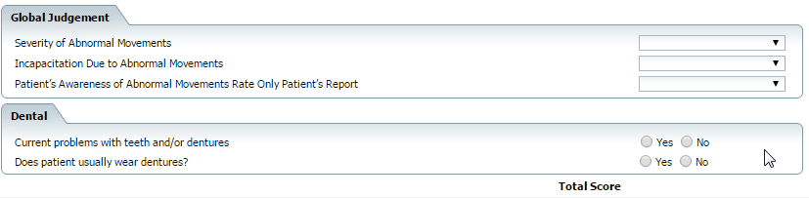

#### Requirements

|  |  |  |  |  |  |  |
| --- | --- | --- | --- | --- | --- | --- |
| Field | Required | Response Options | Global Code  Category | Validation Message | Initial Document Initialization | Push Data To / Action on Signature |
| Muscle of Facial Expression (e.g., movements of forehead, eyebrows, periorbital area, cheeks; including frowning, blinking, smiling, grimacing) | Yes | Via dropdown   * 0 - None * 1 – Minimal, maybe extreme normal * 2 - Mild * 3- moderate * 4- Severe | xAIMSMovements | Note-Exam-AMIS-Muscle of Facial Expressions is required | None | None |
| Lips and Perioral Area (e.g., puckering, pouting, smacking) | Yes | Via dropdown   * 0 - None * 1 – Minimal, maybe extreme normal * 2 - Mild * 3- moderate * 4- Severe | xAIMSMovements | Note-Exam-AMIS-Lips and Perioral Area is required | None | None |
| Jaw (e.g., biting, clenching, chewing, mouth opening, lateral movement) | Yes | Via dropdown   * 0 - None * 1 – Minimal, maybe extreme normal * 2 - Mild * 3- moderate * 4- Severe | xAIMSMovements | Note-Exam-AMIS-Jaw is required | None | None |
| Tongue (e.g., Rate only increase in movement both in and out of mouth, NOT inability to sustain movement) | Yes | Via dropdown   * 0 - None * 1 – Minimal, maybe extreme normal * 2 - Mild * 3- moderate * 4- Severe | xAIMSMovements | Note-Exam-AMIS-Tongue is required | None | None |

#### Extremity Movements Requirements

|  |  |  |  |  |  |  |
| --- | --- | --- | --- | --- | --- | --- |
| Field | Required | Response Options | Global Code  Category | Validation Message | Initial Document Initialization | Push Data To / Action on Signature |
| Upper (arms, wrists, hands, fingers) Include choreic movements, (i.e. rapid, objectively purposeless, irregular, spontaneous), athetoid movements (I.e. slow, irregular, complex, serpentine) Do NOT include tremor (i.e. repetitive, regular, rhythmic) | Yes | Via dropdown   * 0 - None * 1 – Minimal, maybe extreme normal * 2 - Mild * 3- moderate * 4- Severe | xAIMSMovements | Note-Exam-AMIS-Muscle of Facial Expressions is required | None | None |
| Lower (legs, knees, ankles, toes) e.g., lateral knee movement, foot taping, heel dropping, foot squirming, inversion and eversion of foot | Yes | Via dropdown   * 0 - None * 1 – Minimal, maybe extreme normal * 2 - Mild * 3- moderate * 4- Severe | xAIMSMovements | Note-Exam-AMIS-Lips and Perioral Area is required | None | None |

#### Trunk Movements Requirements

|  |  |  |  |  |  |  |
| --- | --- | --- | --- | --- | --- | --- |
| Field | Required | Response Options | Global Code  Category | Validation Message | Initial Document Initialization | Push Data To / Action on Signature |
| Neck, Shoulders, Hips (e.g., rocking, twisting, squirming, pelvic gyrations) | Yes | Via dropdown   * 0 - None * 1 – Minimal, maybe extreme normal * 2 - Mild * 3- moderate * 4- Severe | xAIMSMovements | Note-Exam-AMIS-Neck, Shoulders, Hips is required | None | None |

#### Global Judgments Requirements

|  |  |  |  |  |  |  |
| --- | --- | --- | --- | --- | --- | --- |
| Field | Required | Response Options | Global Code  Category | Validation Message | Initial Document Initialization | Push Data To / Action on Signature |
| Severity of Abnormal Movements | Yes | Via dropdown   * 0 – None, Normal * 1 – Minimal * 2 - Mild * 3- moderate * 4- Severe | xAIMSJudgments1 | Note-Exam-AMIS- Severity of Abnormal Movements  is required | None | None |
| Incapacitation Due to Abnormal Movements | Yes | Via dropdown   * 0 – None, Normal * 1 – Minimal * 2 - Mild * 3- moderate * 4- Severe | xAIMSJudgments1 | Note-Exam-AMIS- Incapacitation Due to Abnormal Movements  is required | None | None |
| Patient’s Awareness of Abnormal Movements Rate Only Patient’s Report | Yes | Via dropdown   * 0- No awareness * 1- Aware, no distress * 2- Aware, mild distress * 3- Aware, moderate distress * 4- Aware, severe distress | xAIMSJudgments2 | Note-Exam-AMIS- Incapacitation Due to Abnormal Movements  is required | None | None |

#### Dental Requirements

|  |  |  |  |  |  |  |
| --- | --- | --- | --- | --- | --- | --- |
| Field | Required | Response Options | Global Code  Category | Validation Message | Initial Document Initialization | Push Data To / Action on Signature |
| Current Subjectives with teeth and/or dentures | Yes | Via radio buttons   * Yes * No | None | Note-Exam-AMIS- Current Subjectives with teeth and/or dentures  is required | None | None |
| Does patient usually wear dentures? | Yes | Via radio buttons   * Yes * No | None | Note-Exam-AMIS- Does patient usually wear dentures is required | None | None |

***Rules for AIMS Document***

|  |  |
| --- | --- |
| Rule | Descriptions |
| Initialization | * AIMS document should initializes from the previous signed document |
| Total Score | * Add the dropdown values to calculate a total score, also give one point for each yes selected in the Dental section. |
| Save | * On Save initialize the current value into the Diagnosis Custom Field Tab called ‘AIMS’ |
| Blank AIMS | * If AIMS is blank then RDL should not include AIMS * PDF output/print should not include the AIMS |

#### Diagnosis Tab

Diagnosis tab only pulls in from other psychiatric notes.

## 



#### Requirements

|  |  |  |  |
| --- | --- | --- | --- |
| Field | Required | Response Options | Validation Message |
| Code/Description | Yes | ICD10/DSMV  ICD9/DSMIV | Diagnosis – Please specify a diagnosis code and description |
| Rule Out | No | Via Checkbox | None |
| Remission | No | Via Dropdown – DxRemissionType   * Partial * Full | None |
| Specifier | No | Via Text field | None |
| Type | No | Via Dropdown – DiagnosisType   * Primary/Principle * Additional | None |
| Source | No | Via Text Field | None |
| Severity | No | Via Drop Down – DxSeverity | None |
| Order | Yes | Via Text Field | Diagnosis – Please specify an order |
| Billable | Yes | Via Text Field | Diagnosis – Please specify billable |
| Screening Tools Used | No | Via Text Field | None |
| Other General Medical Conditions | No | Via Text Field | None |
| Psychosocial, Environmental, and Other Factors | No | Via Pop Up – DXFactors | None |
| Comment | No | Via Text Field | None |
| GAF Score | No | Via Text Field | None |
| WHODAS | No | Via Text Field | None |
| CAFAS Score | No | Via Text Field | None |

### E&M Code Evaluation

### Answers to questions within the various tabs and sections will map to E&M Code evaluation and provide appropriate Procedure code to be billed.

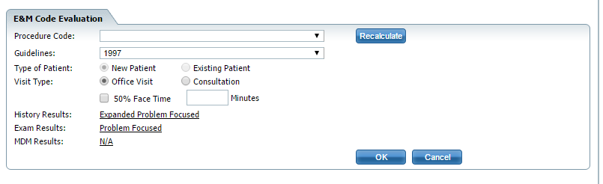

Rules – standard E&M coding stored procedures/rules should be applied

Rules – Psychiatrist to have the ability to override or change the calculated code.

### MAPPING ONLY

### History of Present Illness – E&M Code Tab





MAPPING

|  |  |
| --- | --- |
| **General tab - Subjective - Note** | **History Of Present Illness** |
| Severity | Severity |
| Duration | Duration |
| Modifying Factors | Modifying Factors |
| Time of Day | Timing/Frequency |
| Location | Location |
| Context | Context/Onset |
| Type of Subjective - | Maps to Medical Decision Making |

**Review of Systems E&M Tab**



#### MAPPING

|  |  |
| --- | --- |
| **Review of Systems & Active Medical Problems** | **Review of Symptoms E&M Coding tab** |
| Gastrointestinal | Gastrointestinal |
| Neurological | Neurological |
| Cardiovascular | Cardiovascular |
| Genitourinary | Genitourinary |
| Immune | Allergic/immunologic |
| Hematological | Hematological/Lymphatic |
| Constitutional | Constitutional |
| Skin | Skin |
| Eyes | Eye |
| Musculoskeletal | Musculoskeletal |
| Ear,Nose….. | Ear, Nose…. |
| endocrine | endocrine |
| Respiratory | Respiratory |
| Psychiatric | Psychiatric |

#### Past History E&M Tab



***MAPPING***

|  |  |
| --- | --- |
| **General Tab - History of Present Illness** | **Past History E&M Coding Tab** |
| Family History | Family History |
| Psychiatric History | Medical History |
| Social History | Social History |

#### Exam Section



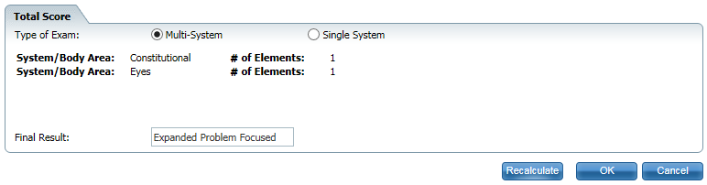

Rules – standard E&M coding stored procedures/rules should be applied

#### Rules

|  |  |  |  |
| --- | --- | --- | --- |
| Field | Rule | Validation  Validation Message | Initializations Occurring on Signature |
| Type of Exam | “Exam” will be automatically calculated based on the selection of the user in the psychiatric MSE section. | None | None |

#### MDM Coding

### 

***MAPPING***

|  |  |
| --- | --- |
| **Medical Records /Orders** | **Data Reviewed** |
| * Medical Records Section – Labs checkbox * Orders – Labs checkbox | Review/Order Clinical Labs |
| * Medical Records Section – Diagnostic Test * Orders Section – EKG * Order Section - Radiology | Review/Order Radiology Test |
| * Collaboration of care | Review/Summarize old records and/or obtain history from someone other than patient and/or discussion of case with another health care provider |





***MAPPING***

|  |  |
| --- | --- |
| **Subjective/Condition** | **Diagnoses/Treatment Options** |
| At least 1 Subjective with status of “new” | New problems |
| Total number of problems = 1 | 1 problems |
| Total number of problems = 2 | 2 problems |
| Total number of problems = 3 | 3 problems |
| Total number of problems = 4 or more | 4 or more problems |
| 1 Subjective with the status of “worsening” | One Established problems Worsening |
| 2 or more problems with the status of “worsening” | Two Established problems Worsening |





***MAPPING***

|  |  |
| --- | --- |
| **Subjectives** | **Presenting Subjectives** |
| Type of Subjective – Acute | 1 acute uncomplicated |
| Type of Subjective – Chronic | 1 Stable Chronic/Major |

|  |  |
| --- | --- |
| **SmartCareRX** | **Risk of Complications/Morbidity/Mortality** |
| Order Medications | Medication Management |